HARDWARE ENGINEERING // DESENSE & INTEGRATION COMPLETE GUIDE
MicroSD Express Integration
Pin Shielding · SE Targets · Antenna Distance
Real Devices · Vendor Specification
UHS-I through PCIe Gen 4 · Wi-Fi 6E · Bluetooth · UWB Coexistence
Nintendo Switch 2 · Samsung Galaxy · Qualcomm QRD · ST AN4541 · IEEE 299

1. MicroSD Connector — All 8 Pins + Card Detect
The microSD connector has 8 signal contacts in a single row plus one card detect switch. In SD Express mode the same physical pins carry a completely different electrical role via protocol negotiation at card insertion. Understanding all three layers (SD mode, UHS-II mode, PCIe mode) is essential before specifying ESD, choke, or shielding requirements per pin.

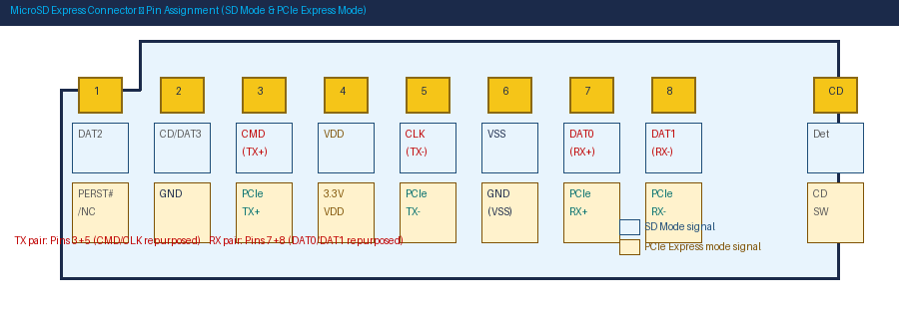
Figure 1 — MicroSD Express 8-pin connector: SD mode vs. PCIe Express mode signal assignment. TX pair (pins 3+5) and RX pair (pins 7+8) are the primary EMI sources in PCIe mode.

1.1 Per-Pin Analysis — Function, Voltage & Protection
Pin | SD Mode | PCIe Express Mode | Voltage | ESD Type | Choke / Filter
1 | DAT2 | PERST# / NC | 3.3V/1.8V | ESD7004 array | NO — series 22Ω resistor in SD mode only
2 | CD/DAT3 | PCIe GND reference | GND in PCIe  3.3V/1.8V SD | ESD array (SD mode) | NO — GND pin: direct via to L2
3 | CMD | PCIe TX+ ↑ | 3.3V/1.8V SD  0.2-1.0V PCML PCIe | SD: ESD7004  PCIe: LXES <0.15pF | YES — CM choke (WURTH 744272100) on TX pair
4 | VDD (3.3V) | VDD (3.3V always) | 3.3V always | TVS on VDD rail | NO — ferrite 600Ω + 100nF decap
5 | CLK | PCIe TX− ↑ | 3.3V/1.8V SD  0.2-1.0V PCML PCIe | SD: ESD7004  PCIe: LXES <0.15pF | YES — TX pair choke (same as Pin 3)
6 | VSS (GND) | VSS (GND always) | 0V always | NO — GND pin | NO — must be lowest inductance path to GND
7 | DAT0 | PCIe RX+ ↑ | 3.3V/1.8V SD  0.2-1.0V PCML PCIe | SD: ESD7004  PCIe: LXES <0.15pF | YES — CM choke (WURTH 744272100) on RX pair
8 | DAT1 | PCIe RX− ↑ | 3.3V/1.8V SD  0.2-1.0V PCML PCIe | SD: ESD7004  PCIe: LXES <0.15pF | YES — RX pair choke (same as Pin 7)
CD | Card Detect (mech) | Card Detect switch | 3.3V pull-up | 100kΩ + 3.3V TVS | NO — DC signal, 100nF debounce cap

KEY | Pins 3+5 (TX pair) and 7+8 (RX pair) are the primary EMI sources at PCIe Gen 4 speeds. Pins 2 and 6 (GND) are the grounding anchors — their via connection quality determines the effectiveness of all shielding. Each GND pin needs a direct, zero-trace via to the L2 GND plane.

1.2 Pin Shielding Priority Order
Pin(s) | Mode | Protection Required | EMI Risk | Priority
3+5 (TX pair) | PCIe | CM choke + LXES ESD + 100nF AC cap | 16 GT/s switching — harmonics at 2.4/6/8 GHz | CRITICAL
7+8 (RX pair) | PCIe | CM choke + LXES ESD + 100nF AC cap | CM noise injection into RX path — degrades sensitivity | CRITICAL
4 (VDD) | All | Ferrite 600Ω + TVS + 100nF/10μF decap | NAND flash switching couples back through VDD | CRITICAL
2+6 (GND) | All | Direct via to L2 — 8-12 vias, max 1.5mm pitch | GND pins ARE the shield anchors — inductance is enemy | MANDATORY
5 (CLK in SD mode) | SD/UHS | 22Ω series R + ESD7004 array | 200 MHz SD clock — 12th harmonic = 2.4 GHz | HIGH
3 (CMD in SD mode) | SD | 22Ω series R + ESD7004 | Hot-plug exposure — bidirectional line | HIGH
1,7,8 (DAT0-2 in SD mode) | SD | 22Ω series R each + ESD7004 array | Moderate EMI — data lines | RECOMMENDED

2. Double-Layer Shielding — Design & Effectiveness
Double-layer shielding places two independent conductive barriers between the PCIe noise source and the wireless receiver. The two SE values are roughly additive in dB (minus inter-layer coupling loss), giving substantially better total attenuation than either layer alone.

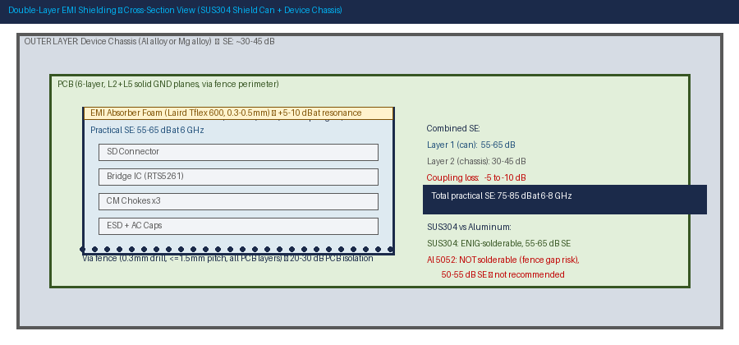
Figure 2 — Double-layer shielding cross-section: SUS304 0.15mm shield can (inner, 55-65 dB) + device chassis (outer, 30-45 dB). Combined practical SE: 75-85 dB at 6-8 GHz. EMI absorber foam inside lid adds 5-10 dB at cavity resonance frequencies.

2.1 Why SUS304 — Not Aluminum
Property | SUS304 (Recommended) | Aluminum 5052 (Not Recommended) | Impact
Solderability (fence to PCB) | Excellent with ENIG plating | Poor — does not wet solder reliably | Al fence cannot solder to PCB pads. Creates seam gap. SE collapses at gap.
SE at 6 GHz (practical) | 55-65 dB (closed seam) | 50-55 dB — further reduced by seam contact resistance | 10-15 dB real-world gap in favor of SUS304
Thickness for SFF | 0.15 mm standard | 0.20-0.25 mm needed for same rigidity | SUS304 saves 0.05-0.10 mm board height
Weight | Medium — higher than Al | Lowest — 3× lighter than SUS304 | Al preferred only if weight is overriding constraint (use conductive gasket, not solder)
Thermal conductivity | 16 W/mK — modest | 138 W/mK — excellent | Use Al only if bridge IC thermal junction temp is critical AND gasket seal is used instead of solder
Plating required | Ni 2-3μm + Au 0.05μm ENIG (solderable) | Chromate conversion or conductive anodize + gasket | Al requires non-solder attachment — mechanical spring clip system

2.2 Shield Can Configuration Options
Option | Layer 1 | Layer 2 | Practical SE @ 6-8 GHz | Best For
A — Recommended | SUS304 0.15mm can + Laird Tflex absorber inside lid | Metal chassis (Al or Mg alloy) + conductive gasket at seams | 75-85 dB | AR/VR with Wi-Fi 6E + UWB — use this
B — PCB-only | SUS304 0.15mm can | Double via fence (1.0mm + 1.5mm rings) | 65-75 dB | Plastic chassis — via fence as second PCB-level layer
C — Minimal | SUS304 0.15mm can | Single via fence 1.5mm pitch | 55-65 dB | Lower frequency bands only — insufficient for UWB
D — Ultra-slim | SUS304 0.10mm can (height critical) | Metal chassis | 65-75 dB | Height budget <1.5mm — structural ribs required in tooling

2.3 Double-Layer SE Calculation
SEtotal = SE_Layer1 + SE_Layer2 - SEcoupling

Example (Option A): SUS304 can + Al chassis
SE_Layer1 (SUS304 0.15mm, good seam): 62 dB at 6 GHz
SE_Layer2 (Al chassis, conductive gasket): 45 dB at 6 GHz
SEcoupling (layers ~8mm apart, RF gasket): -8 dB
SEtotal = 62 + 45 - 8 = 99 dB theoretical
Practical (card mouth aperture + seam variation): ~75-80 dB

This exceeds the 55 dB minimum requirement by ~20 dB margin.
Margin covers manufacturing variation, temperature, and aging.

3. Antenna Keep-Out — Physics & Industry References
The minimum distance between the SD Express subsystem and any wireless antenna element is the most important spatial design decision. Below the required distance, no amount of filtering recovers the desense margin.

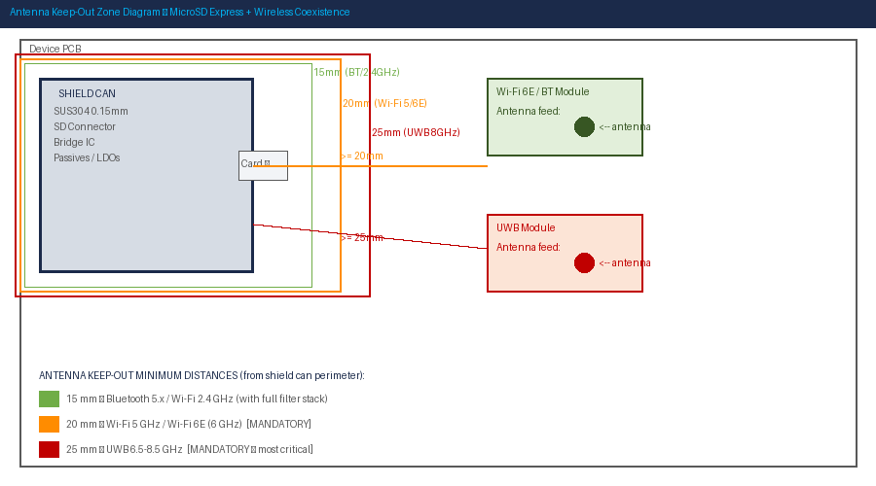
Figure 3 — Antenna keep-out zones from shield can perimeter. Wi-Fi 6E: 20mm minimum. UWB 8 GHz: 25mm minimum. Bluetooth/2.4 GHz: 15mm minimum with full filter stack. All distances measured from shield can perimeter, not connector center.

3.1 Near-Field Boundary Physics
Near-field / Far-field boundary: r = λ / (2π) = c / (2π × f)

At 2.4 GHz: r ≈ 20 mm At 5 GHz: r ≈ 9.5 mm
At 6.0 GHz: r ≈ 8 mm At 8 GHz: r ≈ 6 mm

Inside this boundary: E-field falls at 1/r³ (much stronger than far-field).
Outside this boundary: field falls at 1/r (normal path loss applies).
Keep-out of 20mm at 6 GHz = 12mm margin beyond near-field into far-field.
Path loss at 20mm from 6 GHz aperture: approximately 54 dB.

3.2 Industry Reference Keep-Out Distances
Source | Frequency | Keep-Out Distance | Basis
Qualcomm QRD Reference Design | 5-6 GHz Wi-Fi | >=20 mm from PCIe source to antenna element | Platform simulation + desense measurement validation
Qualcomm QRD Reference Design | 2.4 GHz BT/Wi-Fi | >=15 mm from PCIe clock source to antenna feed | Near-field simulation + measurement correlation
AR/VR industry practice (XR devices) | 2.4/5/6/8 GHz | >=20 mm for Wi-Fi 6E; >=25 mm for UWB | Device-level desense measurements across multiple XR platforms
Intel EMC Design Guide (PCIe) | 2.4-6 GHz | >=15 mm from PCIe slot edge to antenna aperture | Conducted desense measurement data
3GPP TR 36.816 Coexistence | 2.4 GHz | 18-22 mm from source to receive antenna | LTE + Wi-Fi coexistence simulation
ST AN4541 (SD ESD placement) | 100-400 MHz harmonics | ESD device <=3 mm from connector pins | Measured: 8 dB worse at 10mm vs 3mm placement

3.3 Path Loss vs. Distance
Distance from Shield Can | Path Loss @ 2.4 GHz | Path Loss @ 6 GHz | Path Loss @ 8 GHz | Wi-Fi 6E compliant?
5 mm | ~34 dB | ~40 dB | ~42 dB | NO
10 mm | ~40 dB | ~46 dB | ~48 dB | NO
15 mm | ~44 dB | ~50 dB | ~52 dB | Marginal — filter stack required
20 mm | ~47 dB | ~54 dB | ~56 dB | YES
25 mm | ~50 dB | ~57 dB | ~59 dB | YES — preferred

4. Real-World Integration Examples

4.1 Nintendo Switch 2 — First Mainstream SD Express Device (2025)
The Nintendo Switch 2 launched June 2025 and is the most significant real-world SD Express implementation to date. It is the first consumer product shipping with SD Express as its exclusive storage expansion standard. Key design decisions inform AR/VR integration.

Attribute | Nintendo Switch 2 | Design Lesson for AR/VR
SD Standard | microSD Express (SD 7.1) — PCIe Gen 3 x1 (985 MB/s max) | Start with Gen 3 if Gen 4 silicon is unavailable. RTS5261 supports Gen 3. Gen 4 (RTS5263) is the upgrade path.
Host controller | NVIDIA Tegra T239 — SD Express integrated into SoC | Integrated SoC controller eliminates need for discrete bridge IC and external REFCLK routing. Best desense outcome.
Wireless standard | Wi-Fi 6 (2.4 + 5 GHz) + BT 5.3 — NO Wi-Fi 6E | Deliberate choice: avoids 6 GHz REFCLK harmonic conflict entirely. AR/VR cannot make this concession — must use full mitigation stack.
Wireless antenna location | Top bezel — >50 mm from SD slot | Large device allows generous keep-out. AR/VR frame has <30 mm — requires dense shielding stack.
REFCLK approach | SRIS (Separate Reference Clock with Independent SSC) — SoC generates its own REFCLK | SRIS eliminates external REFCLK routing entirely. Zero REFCLK emission on PCB. Implement SRIS if bridge IC supports it.
Mechanical shielding | Metal inner chassis frame surrounds SD slot | Chassis acts as outer Faraday cage (Layer 2). Card mouth faces side edge — away from antenna zone.

4.2 Samsung Galaxy — Why Flagship Phones Removed microSD
Device | microSD? | Reason / Design Implication
Galaxy S23 and later flagships | NO — removed | IP68 water resistance: SD slot creates ingress risk. Keep-out conflict: slot location adjacent to Wi-Fi module left <10 mm separation — failed desense.
Galaxy A54/A55 (mid-range) | YES — UHS-I only | Cost-sensitive segment; UHS-I avoids all PCIe EMI complexity. Viable only if OS/app load speed is not critical.
Qualcomm QRD platform (ref design) | YES — hybrid SIM+SD tray | SD slot at device bottom, Wi-Fi antennas at top — maximum physical separation. PCIe Gen 3 bridge integrated. Antenna keep-out: 20 mm in layout rules.

4.3 ST Microelectronics AN4541 — Measured SD Filter Data
AN4541 Finding | Measured Value | Design Rule
ESD placement — 3 mm vs 10 mm from connector | 8 dB worse at 10 mm | Place ESD array within 3 mm of connector pins. Every extra mm = degraded clamping.
Total capacitance budget (UHS-I SDR104) | 21 pF total (PCB + connector + ESD) | Connector: 0.5 pF. EMIF06-MSD04F3: 7.5 pF. PCB trace: <=13 pF (~20-30 mm trace max).
IEC 61000-4-2 Level 4 clamping (+8 kV) | V_clamp = 28.4V (positive pulse, 30 ns) | Pi-filter ESD structure (two TVS + impedance) reduces clamping vs single TVS. Use EMIF06-MSD04F3 for SD lines.
Data rate impact — demo board parasitic | 62 MB/s vs 81 MB/s baseline (23% reduction) | Even small PCB parasitic trace causes significant throughput loss. Minimize all trace length and capacitance.

5. Connector Pin Shielding — Methods by Preference

5.1 Metal Shell Grounding Requirements
Shell Grounding Parameter | Specification | Why
Via count under shell | 8 minimum, 10-12 optimal | Each via ~0.5 nH. 10 vias in parallel = 0.05 nH — sufficient for 8 GHz.
Via spacing | <=1.5 mm center-to-center along all shell edges | At 8 GHz: λ/20 = 1.875 mm. 1.5 mm provides manufacturing margin.
Via drill | 0.2-0.3 mm to L2 GND plane (direct — no trace routing) | Any trace inductance between shell pad and GND plane degrades HF SE.
Card mouth corners | Highest via density at card-insertion end — vias at all 4 corners | Highest emission concentration at aperture edges.
Shell pad copper | Solid GND pour on L1 under full shell footprint | No signal routing permitted under connector shell.

5.2 Per-Pin Shielding Preference Order
Rank | Method | SE Contribution | Complexity
1st — Best | Ground moat: 8-12 vias under shell + closed via fence perimeter at 1.5mm | 15-25 dB PCB-level isolation | Low — PCB design only
2nd | Double via fence: inner 1.0mm + outer 1.5mm rings, 3-5mm gap | 20-30 dB total inter-zone isolation | Low — PCB design only
3rd | Stripline routing of PCIe pairs on L3 (between L2/L5 GND planes) | 10-15 dB vs microstrip on L1 | Required for Gen 4 anyway
4th | Coplanar GND traces flanking diff pair traces on L1 from connector to first passive | 3-8 dB loop area reduction | Low
5th | Card mouth: extend shield lid 1-2mm over card opening on top side | 3-5 dB aperture reduction | Mechanical design
6th | Card mouth faces away from antenna zone (industrial design permitting) | 5-10 dB effective improvement | Industrial design constraint

6. Reference Documents

6.1 Primary Standards
REFERENCE DOCUMENTS
• SD Association Physical Layer Spec v4.00+ — SD Express pin assignment, PCIe Gen3/4 electrical spec, UHS-I/II compatibility — authoritative spec [sdcard.org/developers]
• PCI Express Base Spec 4.0 (PCI-SIG) — PCIe Gen4 SI requirements: AC coupling, REFCLK, SSC, eye mask — CEM Chapter 4 [pcisig.com (membership)]
• SD Association White Paper — SD Express 8.0 — SD Express architecture, pin reuse strategy — free download [sdcard.org/cms/.../SD_Cards_8_0_WhitePaper20200515.pdf]

6.2 EMI / ESD Application Notes
REFERENCE DOCUMENTS
• ST Microelectronics AN4541 — EMI Filters for SD3.0 — MEASURED ESD placement data, pi filter structure, IEC 61000-4-2 clamping — free PDF [st.com — DocID026513]
• Murata LXES Series ESD Application Note — S-parameters, capacitance vs bias, placement rules for PCIe ESD selection [murata.com — LXES15AAA1-154 product page]
• WURTH 744272100 CM Choke Datasheet — Impedance curves, CM rejection vs diff insertion loss — confirms PCIe REFCLK / TX / RX suitability [we-online.com]

6.3 Layout, EMC & Community
REFERENCE DOCUMENTS
• NVNTLabs Switch2-SDEX2M2 (Open Source) — Open-source schematic: microSD Express breakout for Nintendo Switch 2 — real PCIe routing and grounding reference [github.com/NVNTLabs/switch2-SDEX2M2]
• ANSYS EMI/EMC Co-Existence Simulation (ST White Paper) — ANSYS methodology for modeling PCIe noise coupling to Wi-Fi receiver — matches AR/VR use case [st.com/resource/en/white_paper/ansys_ab-emi-emc-co-existence-simulation-methodology.pdf]
• IPC-2141A — Controlled Impedance PCB — 100Ω differential pair trace width calculation, stackup design, tolerance specification [ipc.org]
• IEEE 299 / ASTM F3057-14 — SE Measurement Standards — Methods for measuring shield can SE — use for validation of shield can assembly before mass production [ieeexplore.ieee.org / astm.org]

7. Quick Reference — All Key Numbers
Parameter | Value | Source / Basis
Shield material | SUS304 stainless steel — NOT aluminum | Industry standard — solderable, adequate SE, SFF height
Shield thickness | 0.15 mm (0.10 mm ultra-slim min) | SE vs height vs rigidity balance
Shield practical SE @ 6 GHz | 55-65 dB (single can, good BeCu contact) | IEEE 299 measurement basis
Double-layer SE @ 6 GHz | 75-85 dB (can + metal chassis) | Combined; SEcoupling ~8 dB subtracted
Required SE — Wi-Fi 6E (6 GHz) | >=55 dB from can alone | Receiver sensitivity + desense budget
Required SE — UWB (8 GHz) | >=50 dB from can alone | UWB sensitivity + desense budget
Antenna keep-out — Wi-Fi 6E | >=20 mm from shield can perimeter | Qualcomm QRD + AR/VR industry practice
Antenna keep-out — UWB 8 GHz | >=25 mm from shield can perimeter | Near-field boundary calculation + path loss
Antenna keep-out — BT/2.4 GHz | >=15 mm with full filter stack | 3GPP TR 36.816 + Qualcomm QRD
Via fence pitch | <=1.5 mm (lambda/20 at 8 GHz = 1.875 mm) | EMI aperture rule
Shell GND vias | 8-12 vias, 0.2-0.3 mm drill | Direct to L2 GND — no trace routing
ESD — PCIe TX/RX lines | Murata LXES15AAA1-154 (<0.15 pF/line) | PCIe Gen4 eye budget — 0.1 pF causes measurable closure
ESD — SD I/O bus | ESD7004 or EMIF06-MSD04F3 (<1.0 pF/line) | SD3.0 capacitance budget = 21 pF total (ST AN4541)
ESD placement — SD lines | <=3 mm from connector pins | ST AN4541 measured: 8 dB worse at 10 mm
ESD placement — PCIe lines | <=1 mm from connector pins (last device before connector) | Murata App Note — trace inductance degrades clamping
CM chokes — mandatory count | 3 (PCIe TX pair + RX pair + REFCLK pair) | WURTH 744272100 or TDK ACM2012H
REFCLK SSC | Enable ±0.25% to ±0.5% | -10 to -15 dB peak emission reduction — always enable
Bridge IC to connector | <=15 mm | Minimizes exposed PCIe trace length
PCIe diff pair impedance | 100 Ohm ±5% | PCI Express Base Spec 4.0
Intra-pair skew | <=5 mil (0.127 mm) | PCI Express Base Spec 4.0

SECTION 8
Vendor Specification — Binding Requirements
EMI Shielding · Antenna Keep-Out · Validation Protocol · Normative References

Scope
This section defines binding shielding and antenna proximity requirements for the microSD Express connector integration. It is intended as a vendor-facing specification. Requirements marked MANDATORY must be met before design approval. This section is self-contained and may be extracted as a standalone vendor document.

8. Vendor Specification — EMI Shield & Antenna Keep-Out Requirements

8.1 Shield Can — Material & Construction
Parameter | Specification | Rationale | Requirement
Shield material | SUS304 (primary) or SUS316 (high humidity) | Solderable with ENIG. Non-magnetic. Adequate SE at 6-8 GHz. SUS316 adds corrosion resistance. | MANDATORY
Thickness | 0.15 mm nominal / 0.10 mm minimum (height-constrained) / 0.20 mm for extra SE | 0.15 mm balances SE, rigidity, height. Below 0.10 mm: insufficient structural rigidity. | MANDATORY
Construction | Two-piece: solder-down fence + snap/press-fit removable lid | Fence is permanent. Lid removable for rework and inspection during DVT/EVT. | MANDATORY
Lid closure | BeCu spring fingers on lid engaging fence lip. Min 8 fingers/long side, 4/short side. | Maintains consistent contact force -40°C to +85°C. | MANDATORY
Fence plating | ENIG: Ni 2-3 μm + Au 0.05-0.1 μm | Required for reliable solder wetting of fence to PCB pads. | MANDATORY
Lid spring plating | Ni 2-3 μm only (no Au on contact surface) | Hard Ni resists wear at BeCu contact. Au wears off in repeated lid removals. | MANDATORY
Side wall apertures | Zero apertures on any shield wall facing antenna elements. Top lid test holes only. | Each aperture = leakage path = SE collapse at that frequency. | MANDATORY
Internal absorber foam | Laird Tflex 600 or equivalent, 0.3-0.5 mm, bonded to inside of lid | Suppresses shield cavity resonance at 6-8 GHz. Adds 5-10 dB SE. | RECOMMENDED

8.2 Shielding Effectiveness (SE) Targets
Minimum practical SE values per IEEE 299 or ASTM F3057-14, measured on production-representative assembly with lid installed, spring fingers engaged, fence soldered.

Frequency | Min SE — Shield Can Alone | Target SE — Double Layer (Can + Chassis) | Primary Band at Risk | Requirement
2.4 GHz | 50 dB | 65 dB | Bluetooth 5.x / Wi-Fi 2.4 GHz (REFCLK 24th harmonic) | MANDATORY
5.0 GHz | 55 dB | 70 dB | Wi-Fi 5 GHz (REFCLK 50th harmonic) | MANDATORY
6.0 GHz | 55 dB | 72 dB | Wi-Fi 6E — most critical band | MANDATORY
8.0 GHz | 50 dB | 68 dB | UWB 8 GHz (PCIe 16 GT/s + REFCLK 80th harmonic) | MANDATORY

NOTE | SE targets must be met independently of the filter stack (SSC, CM chokes, pi filter). The shield is the final containment layer. The filter stack provides an additional 40-50 dB — the shield's SE is the safety net if filter stack performance degrades at temperature or over life.

8.3 PCB Via Fence Requirements
Parameter | Specification | Rationale | Requirement
Perimeter | Closed rectangle surrounding: connector + bridge IC + all passives | Open perimeter = leakage gap = SE collapse. | MANDATORY
Via drill | 0.2-0.3 mm | Smaller = lower inductance per via. | MANDATORY
Via spacing | <=1.5 mm center-to-center | At 8 GHz: λ/20 = 1.875 mm. 1.5 mm provides variation margin. | MANDATORY
Layer connection | Through all PCB layers (L1 to Ln) to L2 and L5 GND planes | Partial-layer stitching creates horizontal EMI slot at gap layers. | MANDATORY
Optional double fence | Inner 1.0 mm pitch + outer 1.5 mm pitch, 3-5 mm separation | Adds 5-8 dB over single fence. Required if single fence fails validation. | RECOMMENDED

8.4 Connector Shell Grounding Requirements
Parameter | Specification | Rationale | Requirement
Via count | 8 minimum, 10-12 optimal | 8 vias in parallel ≈ 0.06 nH — adequate for 8 GHz grounding. | MANDATORY
Via placement | Distributed along all shell pad edges. Max 1.5 mm spacing between adjacent vias. | Clustered vias leave high-inductance gaps between them. | MANDATORY
Via drill | 0.2-0.3 mm to L2 GND plane. Direct barrel-to-plane — no trace routing. | Any trace inductance between shell and GND plane degrades HF SE. | MANDATORY
Card mouth vias | Increase density at card-insertion end. Vias at all 4 corners of card mouth opening. | Highest emission at aperture — highest GND density there. | MANDATORY
Shell pad copper | Solid L1 GND pour under full shell footprint. No signal routing under shell. | Maximizes shell-to-PCB contact. Signal traces under shell = EMI coupling path. | MANDATORY

8.5 Antenna Keep-Out Requirements

Figure 4 (repeated for vendor reference) — Keep-out distances from shield can perimeter. All distances are measured edge-to-edge from shield can perimeter to nearest antenna element (radiating element or feed point).

Wireless Band | Frequency | Minimum Keep-Out | Preferred | Requirement
Wi-Fi 6E | 5.925-7.125 GHz | 20 mm | 25 mm | MANDATORY
UWB | 6.0-8.5 GHz | 25 mm | 30 mm | MANDATORY
Wi-Fi 5 GHz | 5.15-5.85 GHz | 20 mm | 25 mm | MANDATORY
Bluetooth / Wi-Fi 2.4 GHz | 2.4-2.5 GHz | 15 mm (with full filter stack)  20 mm if filter stack not implemented | 20 mm | MANDATORY
GPS / GNSS | 1.2-1.6 GHz | 20 mm | 25 mm | MANDATORY
Cellular (4G/5G sub-6) | 0.7-3.8 GHz | 15 mm | 20 mm | RECOMMENDED

CRITICAL | All distances measured from the SHIELD CAN PERIMETER — not the connector center or bridge IC location. If no shield can is implemented, add 15 mm to all distances and measure from connector footprint edge.

8.6 Validation Requirements
The following measurements are required before design approval. Results must be documented and submitted with the vendor design package.

Test | Method | Pass Criteria | Requirement
Shield can SE | IEEE 299 or ASTM F3057-14. Two-antenna method. Lid installed, spring fingers engaged. Test at 2.4, 5, 6, 8 GHz. | Meet SE targets in Section 8.2 at all frequencies. | MANDATORY
Shell grounding impedance | 4-wire resistance + LCR meter at 10 MHz between card mouth shell tab and PCB GND test point. | Resistance: <50 mΩ. Inductance: <1 nH. | MANDATORY
Via fence isolation | Near-field H-probe scan at 2.4, 6, 8 GHz. Compare power inside vs outside via fence perimeter. | >=20 dB isolation across fence at all frequencies. | MANDATORY
Wireless desense | Measure Wi-Fi/BT/UWB RX sensitivity: (a) SD absent baseline, (b) SD Express active max read throughput. | Desense: <=2 dB @ 2.4 GHz, <=1 dB @ 5 GHz, <=1 dB @ 6 GHz, <=1 dB @ 8 GHz. | MANDATORY
Keep-out distance | Measure from shield can outline to nearest antenna element in each band from PCB Gerber files. | All distances meet Section 8.5 minimums. | MANDATORY
Thermal soak desense | Repeat desense at -20°C, +25°C, +85°C. | Desense within specification at all temperatures. | MANDATORY

8.7 Normative References
Standard | Title / Scope | Clause
SD Association Physical Layer Spec v4.00+ | SD Express pin assignment, PCIe Gen3/4 electrical interface, UHS-I/II compatibility | Full
PCI Express Base Spec 4.0 (PCI-SIG) | PCIe Gen4 SI, AC coupling, REFCLK, SSC requirements | CEM Ch.4
IEEE 299 | Measuring SE of enclosures | Full
ASTM F3057-14 | Shielding effectiveness, 100 kHz to 20 GHz | Full
IEC 61000-4-2 Level 4 | ESD immunity — ±8 kV contact discharge | Level 4
IPC-2141A | Controlled impedance PCB — 100Ω diff pair spec | Section 4
CISPR 32 / EN 55032 | Radiated emission limits — Class B consumer electronics | Section 9
ST AN4541 (STMicroelectronics) | EMI filters for SD3.0 — measured placement data | Full

8.8 Approval Block
Prepared By | Reviewed By | Approved By
Name / Signature | Name / Signature | Name / Signature
Date: ___________ | Date: ___________ | Date: ___________

End of Document — MicroSD Express Integration: Complete Design & Vendor Specification Reference

